Macroinvertebrates as an Indicator of River Health

Matthew Myer, Notre Dame of Maryland University

Abstract
On the Back River in Dundalk, Maryland, the Back River Wastewater Treatment Plant has been functioning since 1911. It is not known how much immediate damage the plant has caused to the ecosystem of the Back River. A good indicator of the health of a body of water is the number and variety of macroinvertebrates that can be found in it. This study examines the water quality of the Back River and compares it to Middle River, which is further away from the wastewater treatment plant. Understanding the connections between water health and biodiversity will allow for preventative measures (if appropriate) that will ensure proper treatment of the waste that is cycled through the Back River Wastewater Treatment Plant.

Introduction/objective/purpose
Since the early 1900’s, millions of gallons of wastewater have been treated at the Back River Wastewater Treatment Plant. This plant is a tertiary means of water treatment and serves residents in Baltimore County and City. The plant sits on the Back River, which feeds directly into the Chesapeake Bay. One step of the water purification process is to aerate the water and send it directly into the Back River.
The presence and quantity of macroinvertebrates is often an indicator of the health of a body of water. “Freshwater macroinvertebrates are used to assess the “health” of a stream [or other body of water]. Taking samples of all aquatic life stages of macroinvertebrates can serve as an indicator of the water quality for several reasons:
- Some are sensitive (intolerant) to pollution, habitat changes, and severe natural events, while others are more tolerant;
- Many live in the water for over a year;
- They are generally sessile – they cannot escape pollution like fish and birds;
- They are easy to collect” (DNR, 2003, p.1).
Within my study, I examine the presence of macroinvertebrates in Back River and Middle River to assess the health of the bodies of water. I also ran several tests on the water to see if the level of macroinvertebrates may directly correlate to the levels of various nutrients and bacteria in the water, which may be attributed to the Back River Wastewater Treatment Plant.
Theoretical Framework
Since the introduction of the Back River Wastewater Treatment Plant in the early 1900’s, processed water has been pumped back into the river. Many studies have been conducted to measure the health of the river. In 2010, in a study conducted by Karrh, it was found that the health of the river was “poor.” (2010, p.2.). This was decided after testing the water with the knowledge that “Nutrient loadings from point sources (including wastewater treatment plants, WWTPs) are the easiest to measure. Point source loads are often the most cost-effective to manage. A major focus of management actions to reduce nutrient loads has been upgrades to WWTPs.” (Karrh, 2010, p.4).
Throughout studies of the Back River Wastewater Plant, levels of nitrogen, phosphorus, sediment, and fecal coliform were tested. Some of the results are as follows:
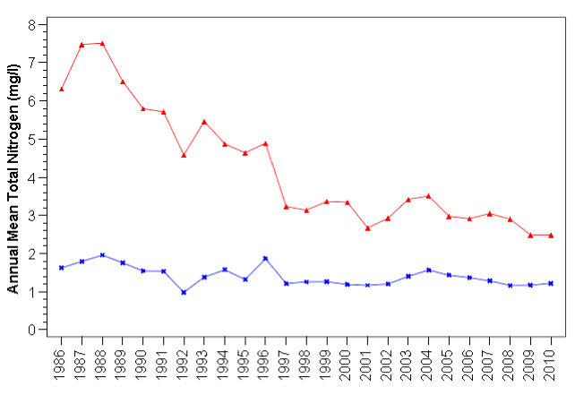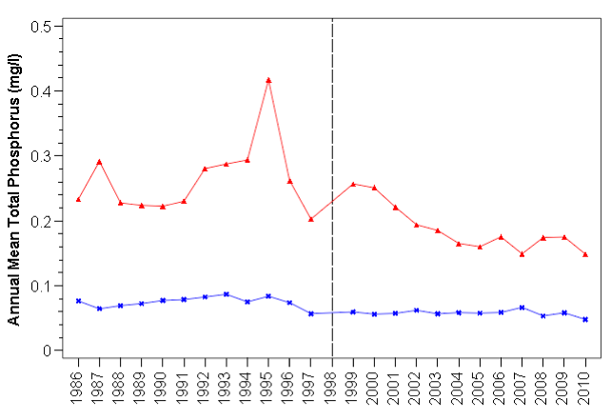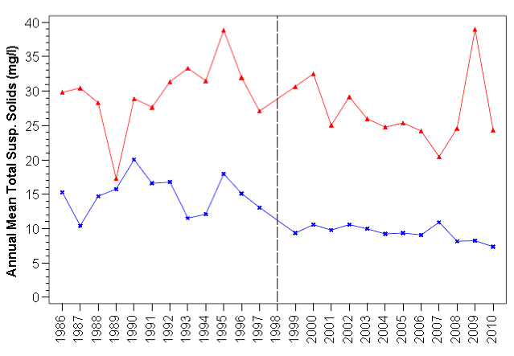
(Karrh, 2010, p.12)
This recent study highlights the fact that there has been a much more increased amount of nitrogen, phosphorus, and sediment in the Back River than could be found in the Patapsco River.
The macroinvertebrates that can be found in rivers can be categorized into three different categories: pollution sensitive, somewhat pollution tolerant, and pollution tolerant. By observing the presence of these various macroinvertebrates, another data point can be made to determine the exact health of the river.
Research Question
- Are the Back River and Middle River healthy bodies of water as measured by the amount of macroinvertebrates found in each?
Methods
Sample: In this study 1400ml of water were collected from both Back River and Middle River. The Back River Wastewater Treatment Plant is on the banks on the Back River, not far from Cox’s Point.
Data Sources: Both samples were tested using the water monitoring kit created by the LaMotte Company. All tests were conducted simultaneously in the same environment. All tests were conducted according to the directions provided in the kit. Samples were also observed and analyzed for the presence of macroinvertebrates, both using a hand lens and a microscope.
Data Analysis: Using the water monitoring kit, tests were conducted to find the levels fecal coliform bacteria, dissolved oxygen, nitrogen, phosphate, pH levels, and sediment. Observations were also performed to analyze the numbers of macroinvertebrates present in the samples.
Results
When looking at the samples, the Back River contained zero macroinvertebrates. The Middle River contained eleven. There are several macroinvertebrates that can be found in bodies of water such as rivers. Table 1 shows the comparison of the two rivers and the numbers of macroinvertebrates that were visible.
Table 1. Comparison of Macroinvertebrates found in Back River and Middle River
 | Dragonfly Nymph | Damselfly Nymph | Mayfly Nymph | Midge Larva
Back River | 0 | 0 | 0 | 0
Middle River | 3 | 4 | 2 | 2

Table 1 provides data indicating that macroinvertebrates are more prevalent in Middle River than Back River. Based on the results, macroinvertebrates, no matter how tolerant to pollution, are more likely to thrive in the ecosystem of the Middle River. No macroinvertebrates are currently living in the water of the Back River near Cox’s Point. This does not mean that there are no macroinvertebrates living in the Back River. More sampling at different point upstream and downstream at different points in the year would need to be conducted in order to deduce that the water health is not conducive for the prolonged life of certain macroinvertebrates.

Levels of fecal coliform bacteria, dissolved oxygen, nitrogen, phosphate, pH levels, and sediment were tested on both water samples. The levels of all in each river vary slightly. Table 2 shows the comparison of both rivers and the levels of all items tested.

Table 2. Comparison of Bacteria and Nutrient Levels in Back River and Middle River
 | Back River | Middle River
Fecal Coliform | Positive (poor) | Negative (good)
Dissolved Oxygen | 81% (good) | 81% (good)
Nitrogen | 5ppm (fair) | 5ppm (fair)
Phosphate | 2ppm (good) | 1ppm (excellent)
pH | 7 (excellent) | 6 (good)
Sediment | 40 JTU (fair) | 0 JTU (excellent)

Table 2 provides data indicating that the Middle River ranks higher when considering the levels as a means of water quality. Back River had more “fair” and “poor” ratings than Middle River. The largest disparity between the data gathered is in the presence of fecal coliform bacteria. High levels of fecal coliform “pose an increased risk of exposure to harmful bacteria and the associated adverse effects” (Gregory, 2000, p.5).
From the data in this research, Back River and Middle River are not very different bodies of water. They are similar in levels of dissolved oxygen, nitrates, phosohates, and pH. The biggest differences are found in the level of fecal coliform and sediment. These two differing levels could be the major contributing factors to the existence of macroinvertebrates found in Middle River compared to Back River.
Conclusions
Data indicates that the health of the Back River is not very good. The lack of macroinvertebrates and the levels of various water health indicators found in this study are two data points that can be used to provide an outcome of water health. The same studies were conducted on a sample from neighboring Middle River. Those studies show that the Middle River is a healthier body of water and provides a better environment for the growth of macroinvertebrates. One contributing factor to poor water health can be linked to the Back River Wastewater Treatment Plant. The daily aeration and resubmission of water from the plant is a routine that should be reevaluated if the Back River is to be revitalized and considered a viable ecosystem that is a major part of the Chesapeake Bay.
Educational and scientific importance
Although brief, this research can be a starting point for the consideration of new wastewater treatment in the Baltimore area. The health of all of the rivers that feed the Chesapeake Bay is vital to the health of the bay itself. It is up to scientific researchers, educators, and civilians to be aware of the affects of wastewater treatment on the fragile ecosystems that are used by millions of people that live in the Chesapeake Bay watershed.

References
Gregory, M. B. (2000). Fecal-coliform bacteria concentrations in streams of the Chattahoochee River National Recreation Area, Metropolitan Atlanta, Georgia, May–October 1994 and 1995. USGS, 1, 1-5.
Karrh, R. (2012). Patapsco and Back Rivers Water Quality and Habitat Assessment. Maryland Department of Natural Resources, 9-15.
Maryland State Evirothon. (2003). Macroinvertebrate Ecology. [Data File]. Retrieved From http://www.dnr.state.md.us/education/envirothon/aquaticinsectecology.pdf

